**Automatic Fruit Freshness Recognition System**

##### **By**

**Usman Safdar CUI/FA17-BCS-106/ATK**

**Aimen Farooq CUI/FA17-BCS-070/ATK**

##### **Supervisor**

**Yasir Ali Shah**

**Bachelor of Science in Computer Science (2017-2021)**



**COMSATS University Islamabad**

**Attock Campus, Pakistan**

**Automatic Fruit Freshness Recognition System**

**A project presented to**

**COMSATS University Islamabad, Attock Campus**

In partial fulfillment

of the requirement for the degree of

Bachelor of Science in Computer Science (2017-2021)

**By**

**Usman Safdar CUI/FA17-BCS-106/ATK**

**Aimen Farooq CUI/FA17-BCS-070/ATK**



**COMSATS University Islamabad**

**Attock Campus, Pakistan**

**UNDERTAKEN**

We hereby declare that this software, neither whole nor as a part has been copied out from any source. It is further declared that we have developed this software and accompanied report entirely based on our personal efforts. If any part of this project is proved to be copied out from any source or found to be reproduction of some other. We will stand by the consequences. No Portion of the work presented has been submitted of any application for any other degree or qualification of this or any other university or institute of learning.

Usman Safdar Aimen Farooq

--------------------------- -------------------------

**FINAL APPROVAL**

It is to certify that the final year project of BS(CS) “Automatic Fruit Freshness Recognition System” is developed by Usman Safdar CUI/FA17-BCS-106/ATK and Aimen Farooq CUI/FA17-BCS-070/ATK under the supervision of “Mr. Yasir Ali Shah”. It is fully adequate, in scope and quality for the degree of Bachelor of Science in Software Engineering.

***Committee:***

1. External Examiner ____________________________

(Examiner Name)

Designation

University Name

2. Supervisor ____________________________

(Supervisor Name)

3. Chairperson ____________________________

(Chairperson Name)

4. Dean/Director ____________________________

(Dean/Director Name)

**DEDICATION**

We dedicate this piece of work to our parents who brought us up in an appropriate educational atmosphere, our worthy teachers who had been a source of encouragement, guidance and enlightenment at each step of our life. Our parents helped us since the beginning of our higher education to cope up with all challenge that we face.

**ACKNOWLEDGEMENT**

Praise be to Allah, the most Beneficent and the most Merciful, the lord of the world, who guides us in the darkness and help us in difficulties. Our all powers are due to His Almighty favors.

We express our deep sense of gratitude to our research supervisor, Mr. Yasir Ali Shah whose valuable guidance and supervision has made this work more colorful and educative. Without his valuable suggestions we believe this study would not have been completed. We are deeply indebted to him for his encouragement and continual help during this work.

Usman Safdar Aimen Farooq

--------------------------- -------------------------

**PROJECT BRIEF**

PROJECT NAME AUTOMATIC FRUIT FRESHNESS RECOGNITION SYSTEM

ORGANIZATION NAME COMSATS UNIVERSITY ISLAMABAD, ATTOCK CAMPUS

OBJECTIVE RECOGNITION OF FRESHNESS OF FRUITS

UNDERTAKEN BY USMAN SAFDAR

CUI/FA17-BCS-106/ATK

AIMEN FAROOQ

CUI/FA17-BCS-070/ATK

SUPERVISED BY MR. YASIR ALI SHAH

LECTURER

COMPUTER SCIENCE

CUI, ATTOCK CAMPUS

STARTED ON OCTOBER 2020

COMPLETED ON EXPECTED APRIL 2021

COMPUTER USED HP AMD RADEON R5,

10 COMPUTE CORES

2.4 GHZ PROCESSOR

8GB RAM

SOURCE LANGUAGE PYTHON 3.8

OPERATING SYSTEM Windows 10

TOOLS USED PYCHARM, PYQT5 DESIGNER,

ANACONDA, MS WORD

PYTHON 3.7 IDE

**ABSTRACT**

Agricultural has always been an important economic and social sector for people. Fruit production is particularly important with high demand from all households. The quality of fruits plays an important role in consumption and thus effects its sales. The world best survival of most of the population is based on agricultural produce. All companies and organizations that manufacture, display, transport or prepare food for sale will have to check the quality of food. If we can determine the ripeness of the fresh fruit, it will be very beneficial to the farmer as they can optimize their harvesting. This ability will help them to avoid harvesting rotten or unrotten fruit. Attempts to use image pre-processing techniques to extract the colour, size and other attributes or features of the training dataset that make up the image, then using supervised and unsupervised learning, we form the trained data from the training dataset. Further the new image of fresh fruit whose quality is to be predicted undergoes image processing later we apply machine learning algorithms on the extracted attributes, referring its outcome and trained dataset quality will be predicted. Nowadays artificial intelligence is a very important technical tool widely used in modern society. Especially deep learning (DL), deep learning is one of the most used ML-based methods. An important DL is characterized by its high level of abstraction and the ability to automatically learn modes exist in the image. It can also learn reliable representation from images, it has many applications. We use classifier algorithm Classifier is a deep learning algorithm that is used to classifies data into a labelled classes or categories of information. Convolution Neural Network (CNN) is the main DL architecture used for image classification. Especially in agricultural CNN-based approaches have been used for fruits classification and fruit detection. The use of CNN for fruit recognition has increased significantly increased achievement of excellent results, both using new models and previous trained networks for transfer learning. Different types of images are used in datasets according to the task performed.

**Table of Contents**

CHAPTER 1 1

INTRODUCTION 1

1.1 Project Background 2

1.3 Relevance to Course Modules 3

1.3.1 Machine Learning 3

1.2.2 Human Computer Interaction 3

1.4 Literature Review 3

1.4.1 Fruit Recognition System 3

1.4.2 Fruit Detection using Deep Learning 4

1.4.3 Deep Fruit Detection in Orchards 4

1.5 Methodology and Software Lifecycle for This Project 4

1.5.1 Methodology 4

1.5.2Rational behind choosing this strategy 5

Chapter 2 6

PROBLEM DEFINITION 6

2.1 Problem Definition 7

2.2 Problem Statement 7

2.3 Deliverables 7

2.3.1 DESKTOP BASED APPLICATION INTERFACE: 7

2.3.2 IMAGE UPLOADING: 7

2.3.3 IMAGE PRE-PROCESSING: 7

2.3.4 SEGMENATION: 7

2.3.5 FEATURE EXTRACTION: 7

2.3.6 CLASSIFIER: 7

2.4 Development Requirements 8

OS Requirement 8

Software Requirements 8

2.5 Current System 8

2.5.1 IMAGE PRE_PROCESSING 8

Chapter 3 9

REQUIREMENT ANALYSIS 9

3.1 Requirement Analysis 10

3.2 Use Case Diagram 10

3.3 Detailed Use Case 11

3.4 Functional Requirements 12

3.4.1 Upload Image 12

3.4.2 Pre-processing 13

3.4.3 Segmentation 13

3.4.4 Feature Extraction 13

3.4.5 Classifier CNN 14

3.4.6 Result/Output 14

3.5 Non-Functional Requirements 14

3.5.1 Efficiency 15

3.5.2 Performance 15

3.5.3 Flexibility 15

3.5.4 Usability 15

3.5.5 Availability 15

3.5.6 Reliability 15

Chapter 4 16

DESIGN AND ARCHITECTURE 16

4.1 Design and Architecture 17

4.2 System Architecture 17

4.3 Process Flow Representation 18

4.4 Design Models [along with descriptions] 20

4.4.1 Sequence Diagram 20

4.4.2 Activity Diagram 21

References 22

**List of Figures**

Figure 1.1 Rotten Apples Image 2

Figure 1.2 Iterative Model 4

Figure 3.1 Use Case Diagram 10

Figure 4.1 System Architecture Diagram 17

Figure 4.2 DFD Level 0 18

Figure 4.3 DFD Level 1 19

Figure 4.4 Sequence Diagram 20

Figure 4.5 Activity Diagram 21

**List of Tables**

Table 3-1 Input Image 12

Table 3-2 Pre-processing 13

Table 3-3 Segmentation 13

Table 3-4 Feature Extraction 13

Table 3-5 Classification CNN 14

Table 3-6 Result 14

**LIST OF ABBREVIATIONS**

|  |  |
| --- | --- |
| **CNN** | Convolutional Neural Network |
| **CAD** | Computer-aided Design |
| **ACC** | Artificial Neural Network |
| **DL** | Deep Learning |
| **DFD** | Data Flow Diagram |
| **FR** | Functional Requirement |

# 

# CHAPTER 1

# INTRODUCTION

## 1.1 Project Background

The largest economic sector of Pakistan is agriculture. It plays an important role in economic growth, not in Pakistan but in many agriculture-dependent countries. It is estimated that nearly a third of fruit costs go to decaying matters. The traditional method of examination of fruits is still done by humans through which many of the unripe fruits are ignored directly. Thus, the sales of fruits are affected as the spoiled fruits are harmful to health. Getting in mind the importance of fruits in people's lives and the overall economic sector fruit freshness recognition becomes an important but traditional method of examination is still by humans as this manual method is time-consuming without the care of fruit health. So, the only suitable solution for this is the Automatic Computerized Approaches using some trained model for the detection of rotten and unrotten fruit.

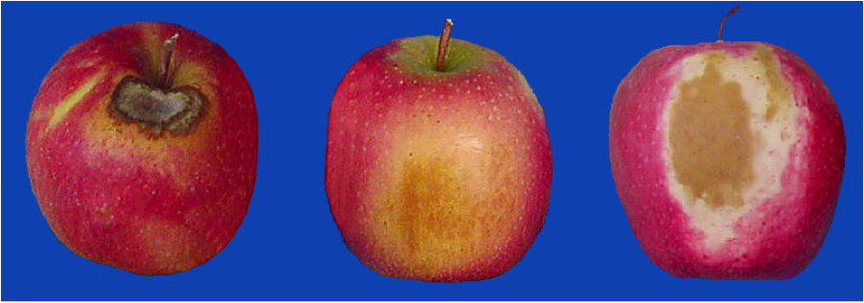

**Figure 1.1 Rotten Apples Image**

**1.2 Brief**

In the overall research, we are analyzing an economic way of detecting the freshness of fruits based on the maturity, shape, and color by using automatic computerized approaches, as the fruit color and shape provide visual property. The techniques might prove efficient to hold the fruit in an unharmed shape as the unmatured manual human method ignores the shape of fruits in most cases. Considering the importance of fruits in people's lives and the economic sector, the manual method of recognition can be replaced by the automatic detection system, in which we have to train a model based on specific qualities (maturity, color, and shape) of fruit using different programming languages codes. That will result in more accuracy and less time than the manual process.

In recent years it has been discovered that deep learning techniques are gradually used to detect many of the situations. Similarly, we will also use deep learning techniques for the recognition of fruit's freshness. The features like the shape and color of the fruits are very critical to checkability. Here we get the shape of the fruit from a digital image while color recognition involves multiple physiological and physical concepts. Now it becomes a difficult process to recognize the colors of the fruits in the digital image, for many different color systems are used for sorting fruit's freshness from one another based on their color.

In the research, we are designing a complete structure based on neural network techniques to recognize the size, color, shape, and maturity of the fruit. We have come across that while recognizing fruit freshness the main factor that matters is its color from the other fruits, but having multiple fruits having the same color makes the recognition difficult for the trained model. So along with color, we are considering the size and shape also to solve this problem, as classification of fruits based on size, shape, and color involves extraction through the physical observation of the fruit through which required information about a particular fruit can be obtained.

Currently, we are using Deep Learning (DL) commonly used Machine Learning (ML) method in our recognition system. Deep Learning Techniques are characterized by their high level of abstraction and the ability to automatically learn and recognize different modes of images once they have been trained. Further in DL, we will use most common method known as the Convolutional Neural Network (CNN) method for the recognition of the fruit’s freshness process. CNN is an Artificial Neural Network (ACC) system that is used to perform convolutional operations, basically used for image recognition, image classifications, object detections, etc.

## 1.3 Relevance to Course Modules

### **1.3.1 Machine Learning**

In Machine learning we had studied about different algorithms which are used to train models to perfume task automatically after getting the training data.

### **1.2.2 Human Computer Interaction**

A system which is interactive is easy and comfortable for the user to use the system and understand it easily and so the course helps us to design an interactive system.

## 1.4 Literature Review

This portion contains the complete related past work and reports that have been completed.

### 1.4.1 Fruit Recognition System

[Y.Song](https://www.sciencedirect.com/science/article/abs/pii/S1537511013002109#!), proposed method for recognizing and counting fruits from images in cluttered greenhouses. The targeted plants are peppers with fruits of complex shapes and varying colors similar to the plant canopy. The aim of the application is to locate and count green and red pepper fruits on large, dense pepper plants growing in a greenhouse. The approach to find the pepper fruits in a single image is based on a combination of finding points of interest, applying a complex high-dimensional feature descriptor of a patch around the point of interest and using a so-called bag-of-words for classifying the patch.

### 1.4.2 Fruit Detection using Deep Learning

Inkyu Sa, presents a novel approach for detecting fruits from images using deep neural networks. For this purpose, the author adapts a Faster Region-based convolutional network. The objective is to create a neural network that would be used by autonomous robots that can harvest fruits. The network is trained using RGB and NIR (near infra-red) images. The combination of the RGB and NIR models is done in 2 separate cases: early and late fusion. Early fusion implies that the input layer has 4 channels: 3 for the RGB image and one for the NIR image. The result is a multi-modal network 4 which obtains much better performance than the existing networks.

### 1.4.3 Deep Fruit Detection in Orchards

Bargoti S, proposed autonomous robots used for harvesting. It shows a network trained to recognize fruits in an orchard. This is a particularly difficult task because in order to optimize operations, images that span many fruit trees must be used. In such images, the amount of fruits can be large, in the case of almonds up to 1500 fruits per image. Also, because the images are taken outside, there is a lot of variance in luminosity, fruit size, clustering and viewpoint.

## 1.5 Methodology and Software Lifecycle for This Project

Project methodology is an important phase of any project because it is a key element for the overall results of the project. For this it is important to understand the concepts and the steps to achieve the goals of our project.

### 1.5.1 Methodology

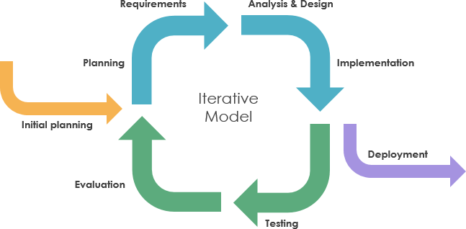

**Figure 1.2 Iterative Model**

* We would be using Iterative Model because Requirements of Software are first broken down into several chunks that can be incrementally constructed and delivered. At any time, the plan is made just for the next increment and not for any kind of long-term plans. Therefore, it is easier to modify the version as per the needs.

### 1.5.2Rational behind choosing this strategy

* We select this methodology because our requirements are clear so through this the development will be fast and easy to test and debug as compare to developing the whole software.
* In this methodology we will develop application through repetitive increments that in first increment we will develop interface in second increment we will add functionalities that a system will perform.

# 

# Chapter 2

# PROBLEM DEFINITION

## 2.1 Problem Definition

The main aim of our project is to automatically recognize the fruit's freshness. This system will detect whether the fruit is rotten or unrotten, based on the shape, physical appearance, size, and color of the fruits.

## 2.2 Problem Statement

As technology evolution is getting fast day by day as people are getting more dependent on technology. Technologies are moving toward automatic systems. As most of the economic sector and people all over the world rely on fruits as the quality of the fruits is necessary, but to analyze the fruits still old traditional methods are used by the farmers or customers that consume more time and effort. So, in this research, our main aim is to identify the problems related to the automatic fruit freshness system. This will help farmers, later on, the wholesale dealers, and in the end, the customers to check the fruit freshness based on its maturity, color, size, and shape. There is a need to expand the different types of visual characteristics such as color, texture, size, and shape to distinguish between a rotten and unrotten fruit.

## 2.3 Deliverables

### 2.3.1 DESKTOP BASED APPLICATION INTERFACE:

A Desktop application will allow the user to evaluate the application in the perspective of easiness and how the application look alike.

### 2.3.2 IMAGE UPLOADING:

Variety of images of fruits required for the detection of their Freshness.

### 2.3.3 IMAGE PRE-PROCESSING:

The images are pre-processed for the accurate and efficient results.

### 2.3.4 SEGMENATION:

To create the segments of the image.

### 2.3.5 FEATURE EXTRACTION:

Extract the features of images based on color, size, texture and shape.

### 2.3.6 CLASSIFIER:

The image is classified completely to recognize fruits freshness and classify the fruits.

## 2.4 Development Requirements

Following are the requirements which the user of the system must fulfill in order to run the system on their laptops or PCs.

## OS Requirement

WINDOWS OS

## Software Requirements

Interface: PyQt Designer IDE: PyCharm,

Dataset based work,

Programming,

Anaconda

Language: Python

**Other Requirements**

For presentation, we will use MS Word and MS Power Point

## 2.5 Current System

Following is the related current systems of our project.

### 2.5.1 IMAGE PRE_PROCESSING

The system can

* Upload and remove an image
* Pre-Process the image
* Resize the image
* Conversion from BGR to Grey
* Contrast Enhancement
* Remove Noise
* Clear the results if required

# 

# Chapter 3

# REQUIREMENT ANALYSIS

## 3.1 Requirement Analysis

Software Requirement Analysis (SRS) provides the basic understanding of functional as well as non -functional requirements. We can consider it as a starting point of project because it serves a written contract between client and organization about the features and functionalities of the project. With the help of SRS both client and organization make clear to each other about the deliverable project.

## 3.2 Use Case Diagram

The use case diagram of our system is given below. The user will input fruit image from system directory to application. After giving an input to a system, system must start pre-processing process. The pre-processed image will be passed for segmentation. Next step is a segmented image is sent to classifier for extracting features and then classify fruit freshness into different types. Result is displayed after correct classification of fruit freshness classes along with their labels and accuracies.

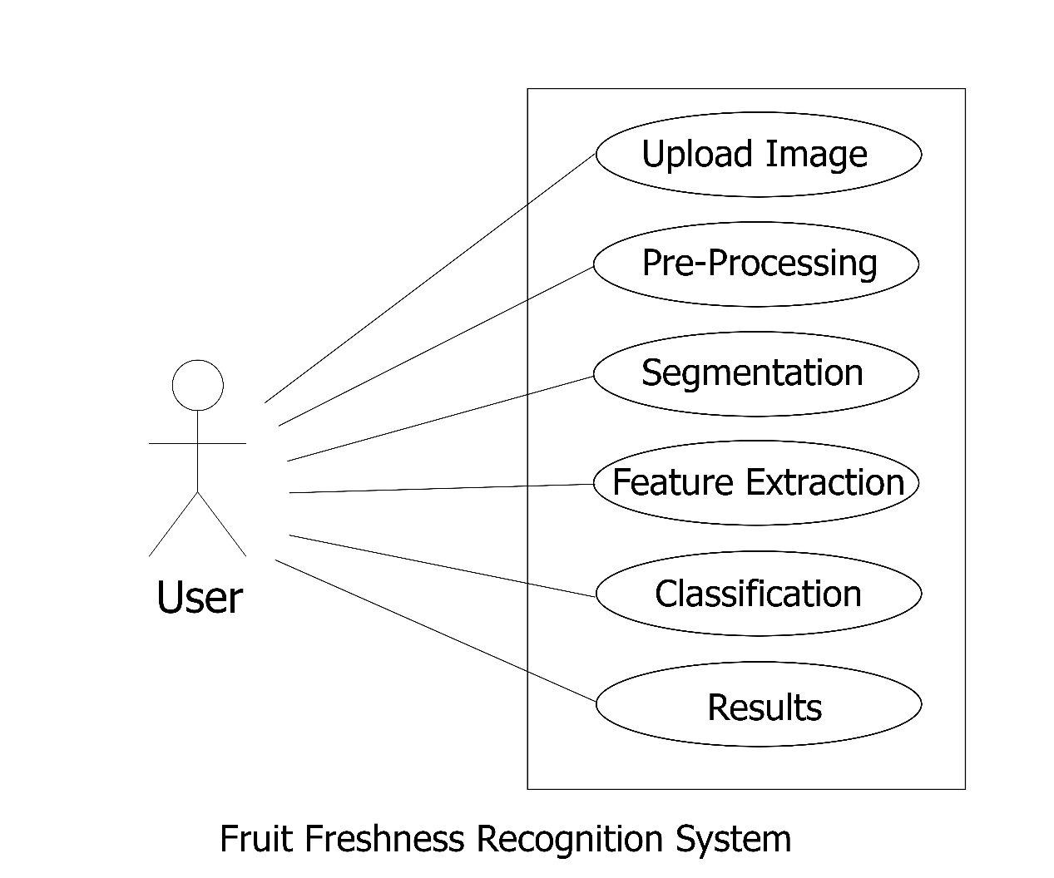

**Figure 3.1 Use Case Diagram**

## 3.3 Detailed Use Case

**1-Use case name:** Input Fruit Image.

**Priority:** 1

**Action:** User

**Summary:** User will input image from system directory to application as initial step to use this application.

**Pre-condition:** User must provide a fruit image to a system as an input and it must be .jpg format.

**Post-condition:** After giving an input to a system, then system must start pre-processing process.

**2-Use case name:** Pre-processing

**Priority:** 2

**Action:** Computer-aided system.

**Summary:** User will input image for pre-processing.

**Pre-condition:** User must provide a fruit image to a system as an input, it must be .jpg format.

**Post-condition:** System can start pre-processing process after giving an input image of fruit.

**3-Use case name:** Segmentation

**Priority:** 2

**Action:** Computer-aided system

**Summary:** The pre-processed image will be passed for segmentation.

**Pre-condition:** User must provide a pre-processed image to a system; it must be in .jpg format.

**Post-condition:** System can start segmentation process after giving a pre-processed image of fruit.

**4-Use case name:** Feature Extraction

**Priority:** 2

**Action:** Computer-aided system

**Summary:** Segmented image is sent for extracting features and then classifying fruits.

**Pre-condition:** User must provide a segmented image of the fruit to the system; it must be in .jpg format.

**Post-condition:** System can start feature extraction after giving a segmented image of fruit.

**5-Use case name:** Classification

**Priority:** 2

**Action:** Computer-aided system

**Summary:** Segmented image is sent to classifier for extracting features and then classifying fruit into different types.

**Pre-condition:** All labels must be assigned to each fruit class and placed in separate directories for testing and training data.

**Post-condition:** After classification on testing and training the labels are classified.

**6.Use-case name**: Result

**Priority:** 2

**Action**: Computer-aided system

**Description**: After classification of each of the features the fruits, labels are matched with the trained model for accuracy and generating the results.

**Pre-condition:** Labels must be classified correctly before getting results.

**Post-condition**: Result is displayed after classification of fruit with their labels and accuracies.

## 3.4 Functional Requirements

Functional requirements are those requirements that our system must do. The functional requirements of our system include;

* The system will take image.
* Perform Pre-processing.
* Perform Segmentation.
* Perform Feature Extraction
* Classification will be performed based on Pre-Processing, Segmentation and Feature extraction for the detection of Fruit Freshness.

### 3.4.1 Upload Image

The user will upload an image of fruit for

**Table 3-1 Input Image**

|  |  |
| --- | --- |
| Title | Input image |
| Identifier | FR-1 |
| Requirements | Uploading the Image |
| Dependencies | None |

### 3.4.2 Pre-processing

Pre-processing is the first important part of our system framework. This process is used to refine irrelevant data, missing values, and noise from data. We use it in our system for image resizing, colour, noise removal and contrast enhancement.

**Table 3-2 Pre-processing**

|  |  |
| --- | --- |
| Title | Pre-processing |
| Identifier | FR-2 |
| Requirements | The system takes image |
| Dependencies | FR-1 |

### 

### 3.4.3 Segmentation

Term Image segmentation refers to the portioning of an image into groups of pixels which are homogenous with respect to some criteria. The objective of segmentation is to extricate as well as change the portrayal of an image into more significant and easier to examine. It subdivides the region of pixels into smaller regions.

**Table 3-3 Segmentation**

|  |  |
| --- | --- |
| Title | Segmentation |
| Identifier | FR-3 |
| Requirements | The system takes a pre-processed image |
| Dependencies | FR-2 |

### 3.4.4 Feature Extraction

Feature defines the behavior of image. To determine the subset of initial features is known as feature selection. Feature extraction refers to extraction of features based on pixels. To save the computational cost, take the tumor region and extract its features and interpret them. This is done to isolate desired portion from an input image.

**Table 3-4 Feature Extraction**

|  |  |
| --- | --- |
| Title | Feature Extraction |
| Identifier | FR-4 |
| Requirements | The system takes a segmented image |
| Dependencies | FR-3 |

### 3.4.5 Classifier CNN

In neural networks, Convolutional Neural Network (CNNs) is one of the main categories to do images recognition, images classifications. Objects detections, recognition faces etc., are some of the areas where CNNs are widely used. The system performs the classification and predict the fruit freshness.

**Table 3-5 Classification CNN**

|  |  |
| --- | --- |
| Title | Classifier CNN |
| Identifier | FR-5 |
| Requirements | The system takes pre-processed image |
| Dependencies | FR-2 |

### 

### 3.4.6 Result/Output

In the end results will be generated based on the classification of the fruit, proving the fruit to be rotten or unrotten.

**Table 3-6 Result**

|  |  |
| --- | --- |
| Title | Result |
| Identifier | FR-6 |
| Requirements | Classifier predicts the fruit freshness and display the result. |
| Dependencies | FR-5 |

## 

## 3.5 Non-Functional Requirements

Non-Functional requirements are those requirements that specify the quality of the system. Following are the non-functional requirements of our system.

### 3.5.1 Efficiency

This system is efficient as it does not require any kind of effort to use it and user friendly.

### 3.5.2 Performance

Performance of our system is efficient taking less time to perform actions.

### 3.5.3 Flexibility

The system provides the user to load the image easily, preform pre-processing, perform segmentation, extract features, perform classification and easily changeable.

### 3.5.4 Usability

This system is user friendly so that user will not face any difficulty while using the system.

### 3.5.5 Availability

Our system will be available in the Food Markets.

### 3.5.6 Reliability

Our system will recover itself in less time in case of any failure. Our system will be reliable enough to use.

# 

# Chapter 4

# DESIGN AND ARCHITECTURE

## 4.1 Design and Architecture

After gathering all requirements, the next step is to start planning how we are going to develop our project, how much resources, costs, time, benefits, and other items are required. Onwards we move to the designing and architecture phase that which techniques and methods we can use and how we are going to develop our project. This phase really matters while starting the development.

## 4.2 System Architecture

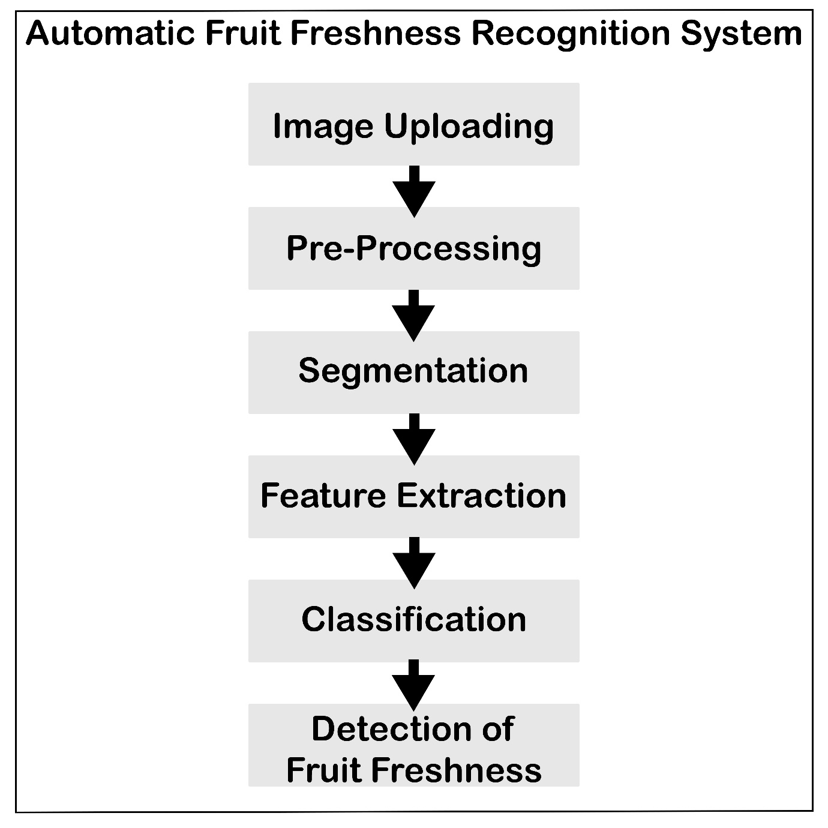

**Figure 4.1 System Architecture Diagram**

## 4.3 Process Flow Representation

A data flow diagram is graphical interpretation of information move from a data framework is called data flow diagram. A DFD is used for basic step to create an overview of the system without going into great aspect, which can later be elaborated.

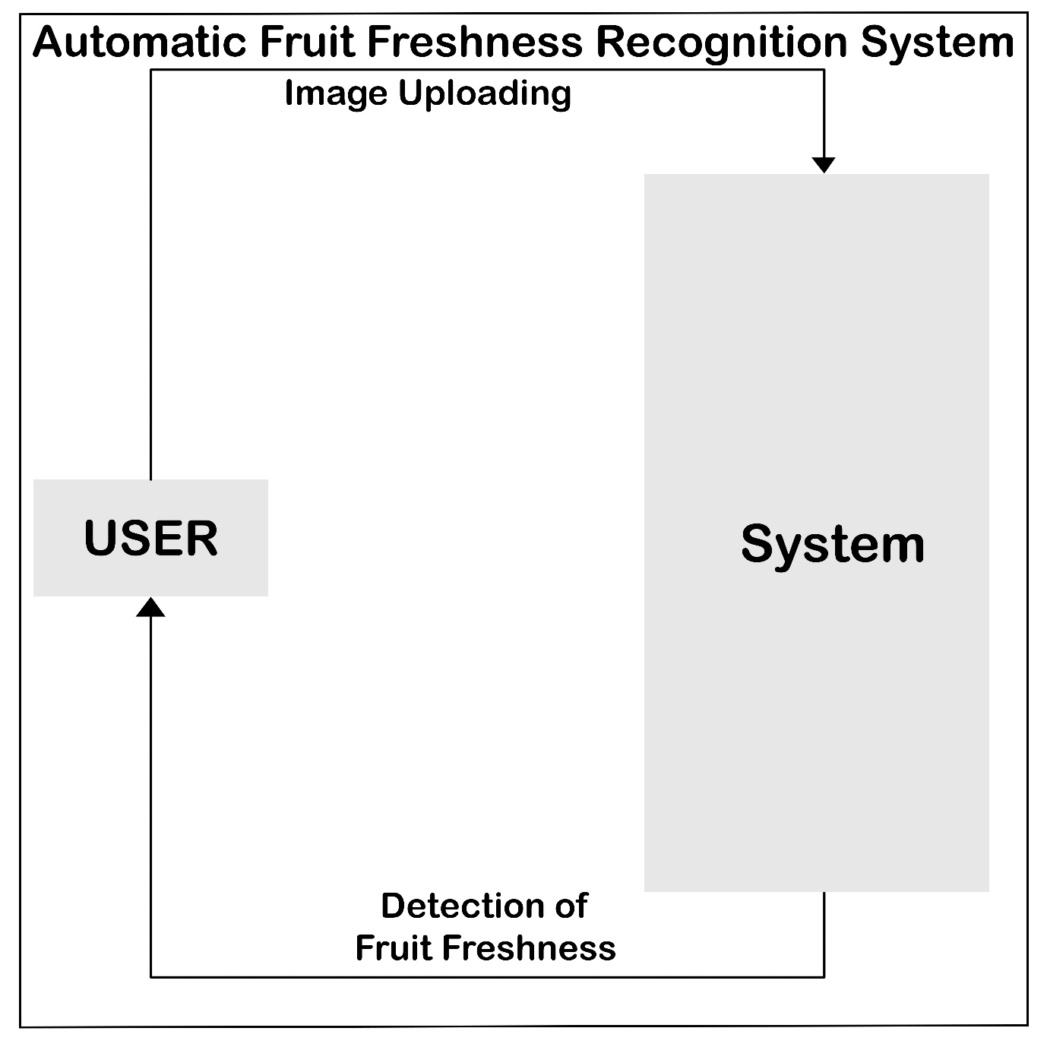

**Figure 4.2 DFD Level 0**

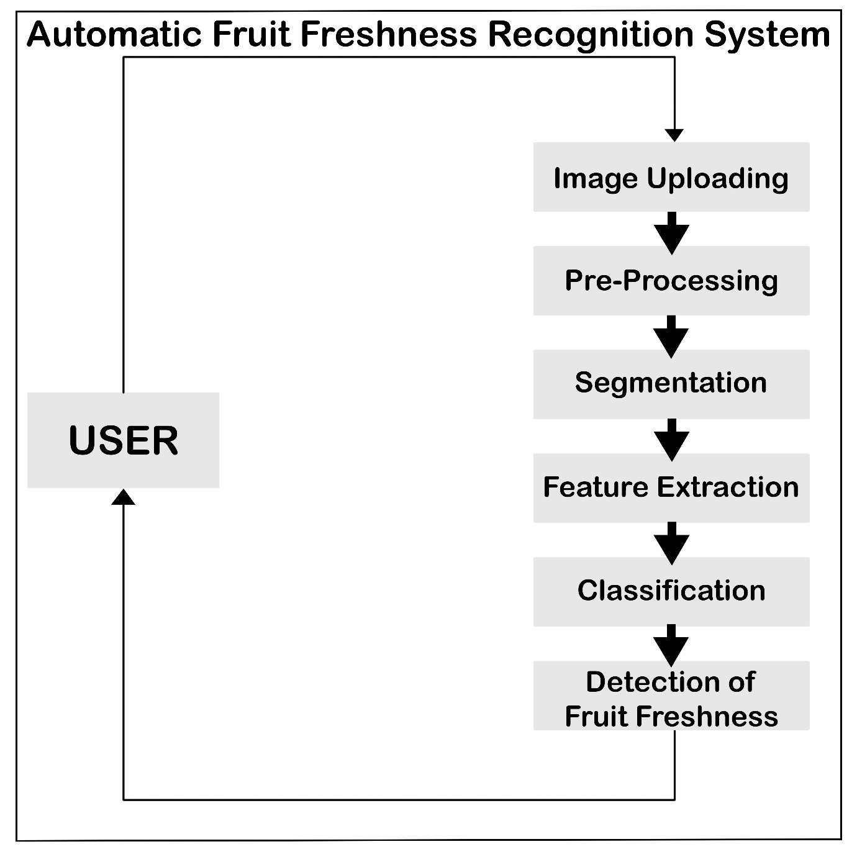

**Figure 4.3 DFD Level 1**

## 4.4 Design Models [along with descriptions]

Following are the design models of our system.

### 4.4.1 Sequence Diagram

The figure given below is the sequence diagram of our system. The user will first upload an image that will go through the pre-processing, segmentation, feature extraction, and classification recognizing the freshness of the fruits, along this user can get results of a single actions at a time.

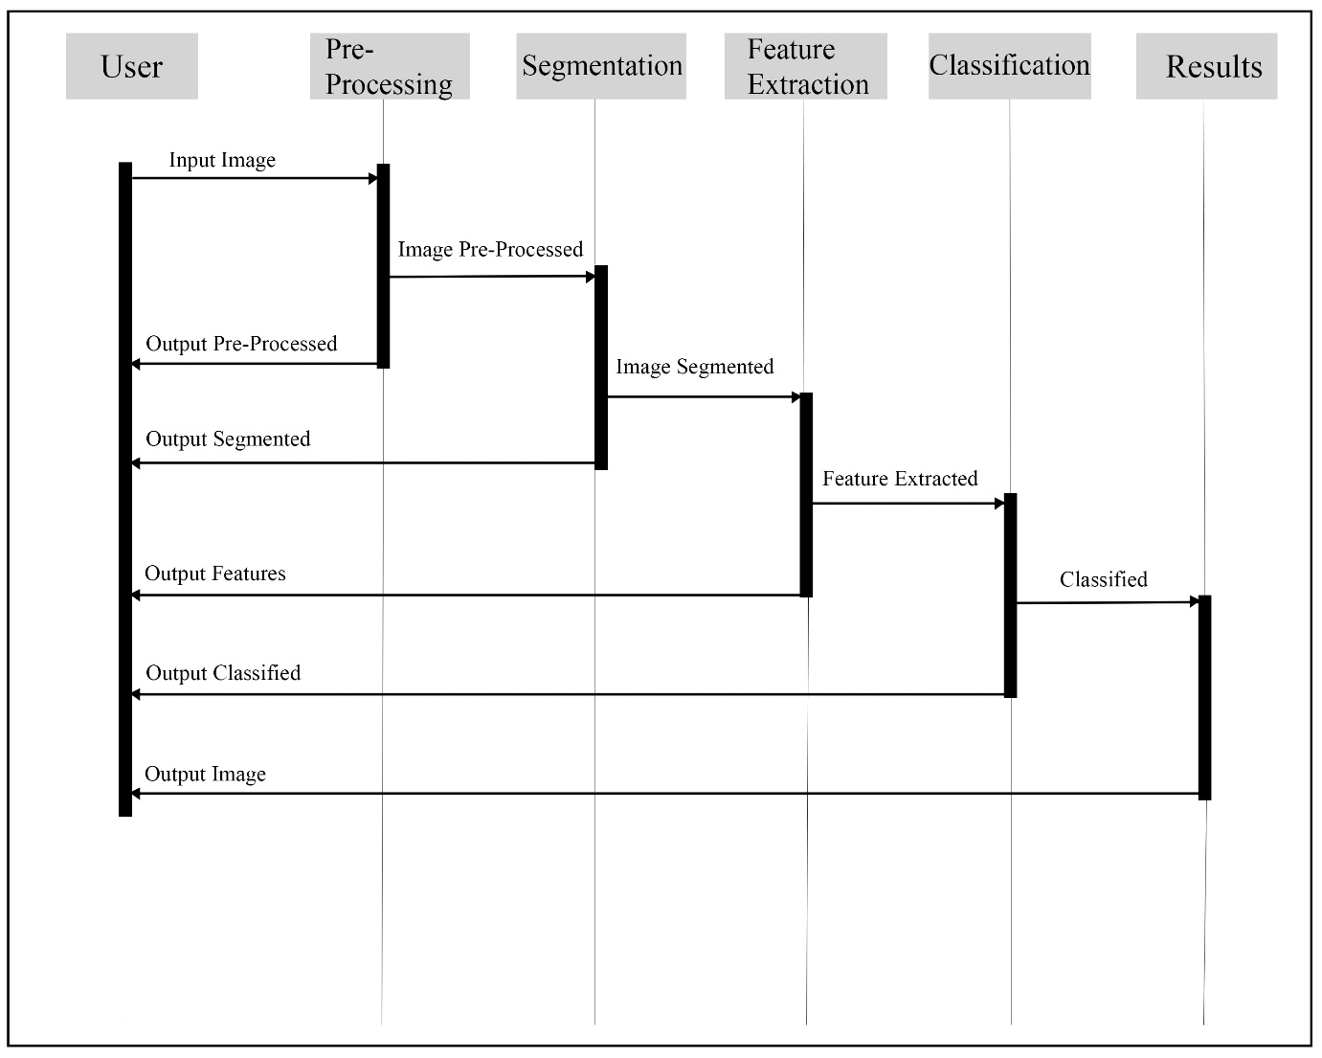

**Figure 4.4 Sequence Diagram**

### 4.4.2 Activity Diagram

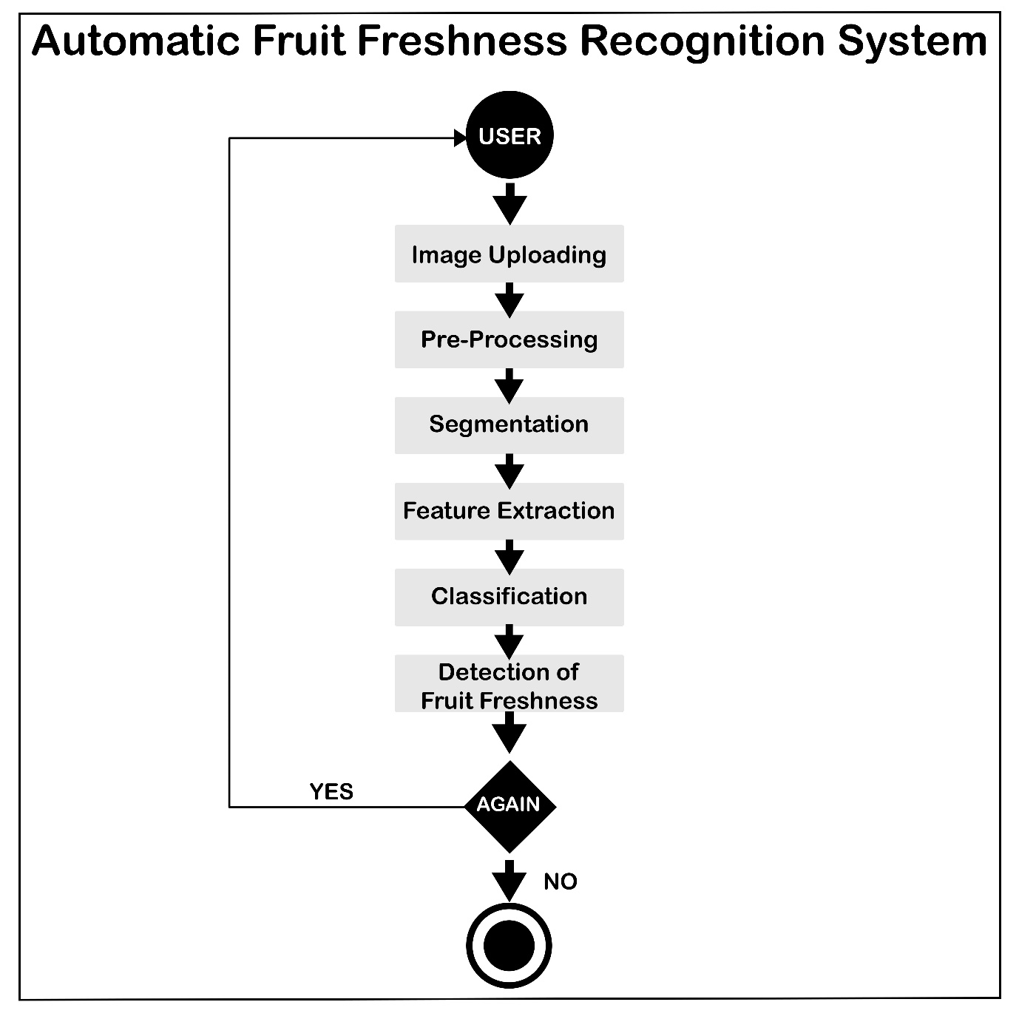

**Figure 4.5 Activity Diagram**

# References

1. Sa, I., Ge, Z., Dayoub, F., Upcroft, B., Perez, T., & McCool, C. (2016). DeepFruits: A Fruit Detection System Using Deep Neural Networks. Sensors, 16(8), 1222. https://doi.org/10.3390/s16081222
2. Song, Y., Glasbey, C. A., Horgan, G. W., Polder, G., Dieleman, J. A., & van der Heijden, G. W. A. M. (2014). Automatic fruit recognition and counting from multiple images. Biosystems Engineering, 118, 203–215. https://doi.org/10.1016/j.biosystemseng.2013.12.008
3. Bargoti, S., & Underwood, J. (2017). Deep fruit detection in orchards. 2017 IEEE International Conference on Robotics and Automation (ICRA). https://doi.org/10.1109/icra.2017.7989417
4. h Fu, Y., 2020. Fruit Freshness Grading Using Deep Learning. [ebook] School of Engineering, Computer and Mathematical Sciences. Available at: <https://openrepository.aut.ac.nz/bitstream/handle/10292/13353/Fruit_Fu_24May2020_wyan.pdf> [Accessed 7 October 2020].
5. Kalluri, S. R. (2018, August 24). Fruits fresh and rotten for classification. Retrieved October 7, 2020, from https://www.kaggle.com/sriramr/fruits-fresh-and-rotten-for-classification